# MiGMB design document

Objective - AdsInfra team would like to have the ability to monitor and alert on MiGMB in Near Real Time

architecture proposal

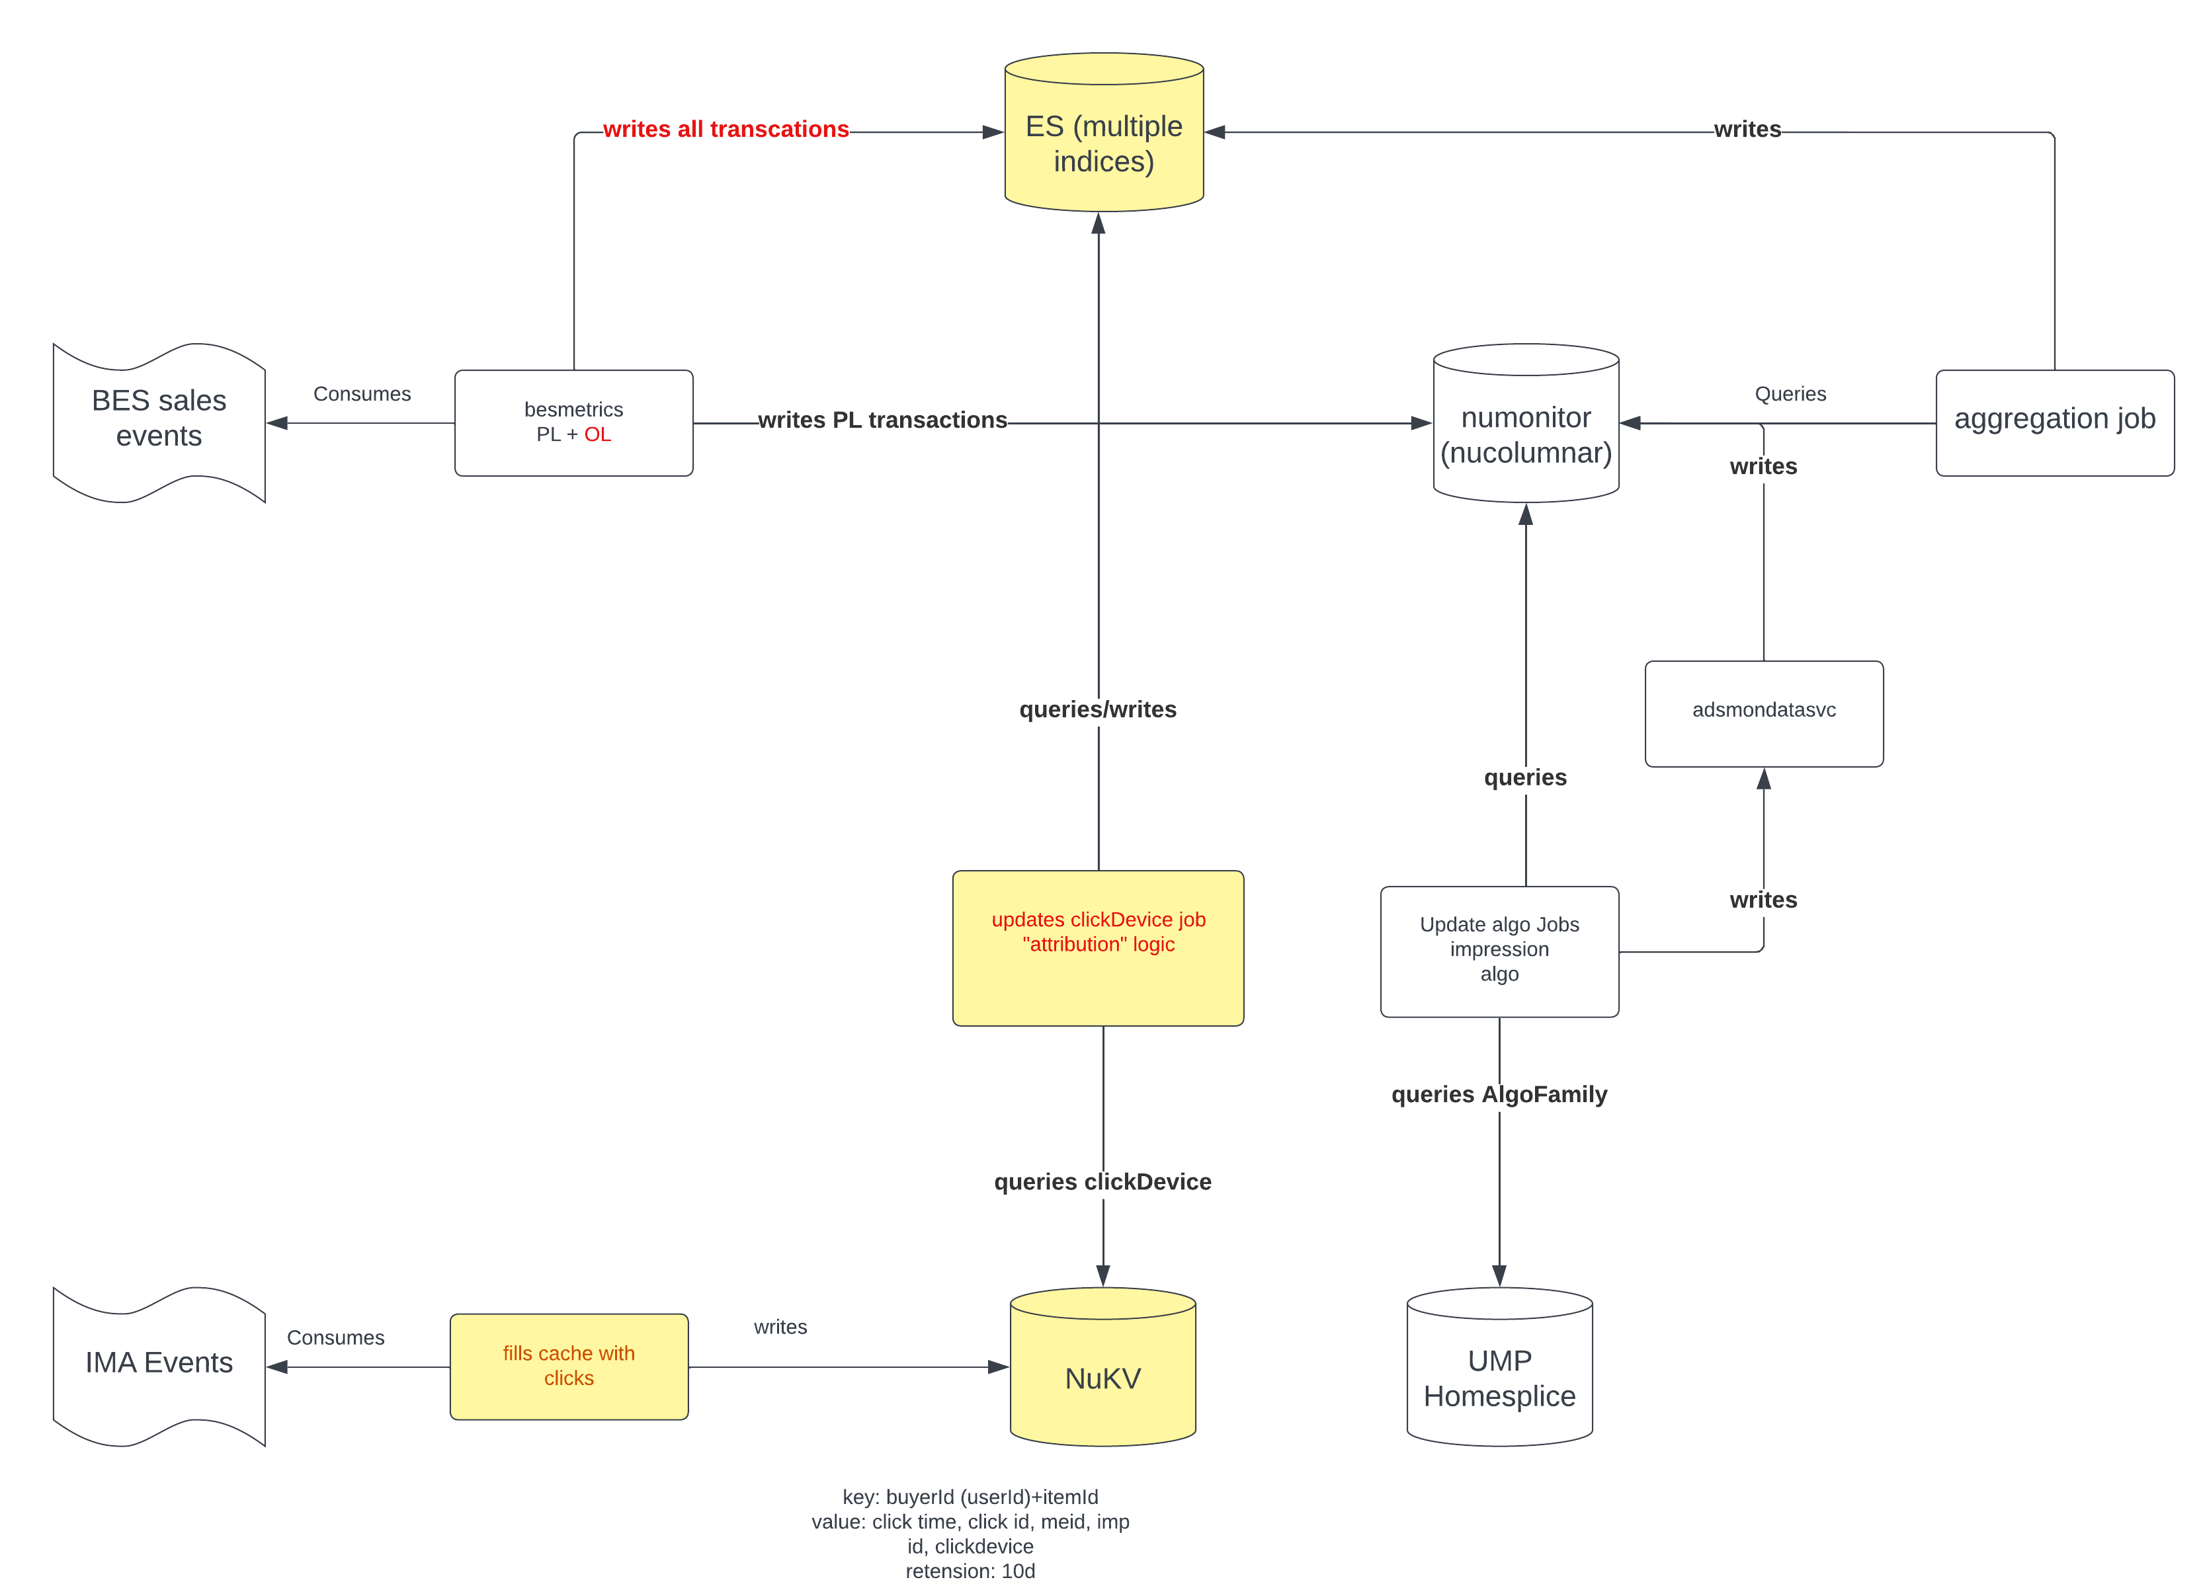

implementation

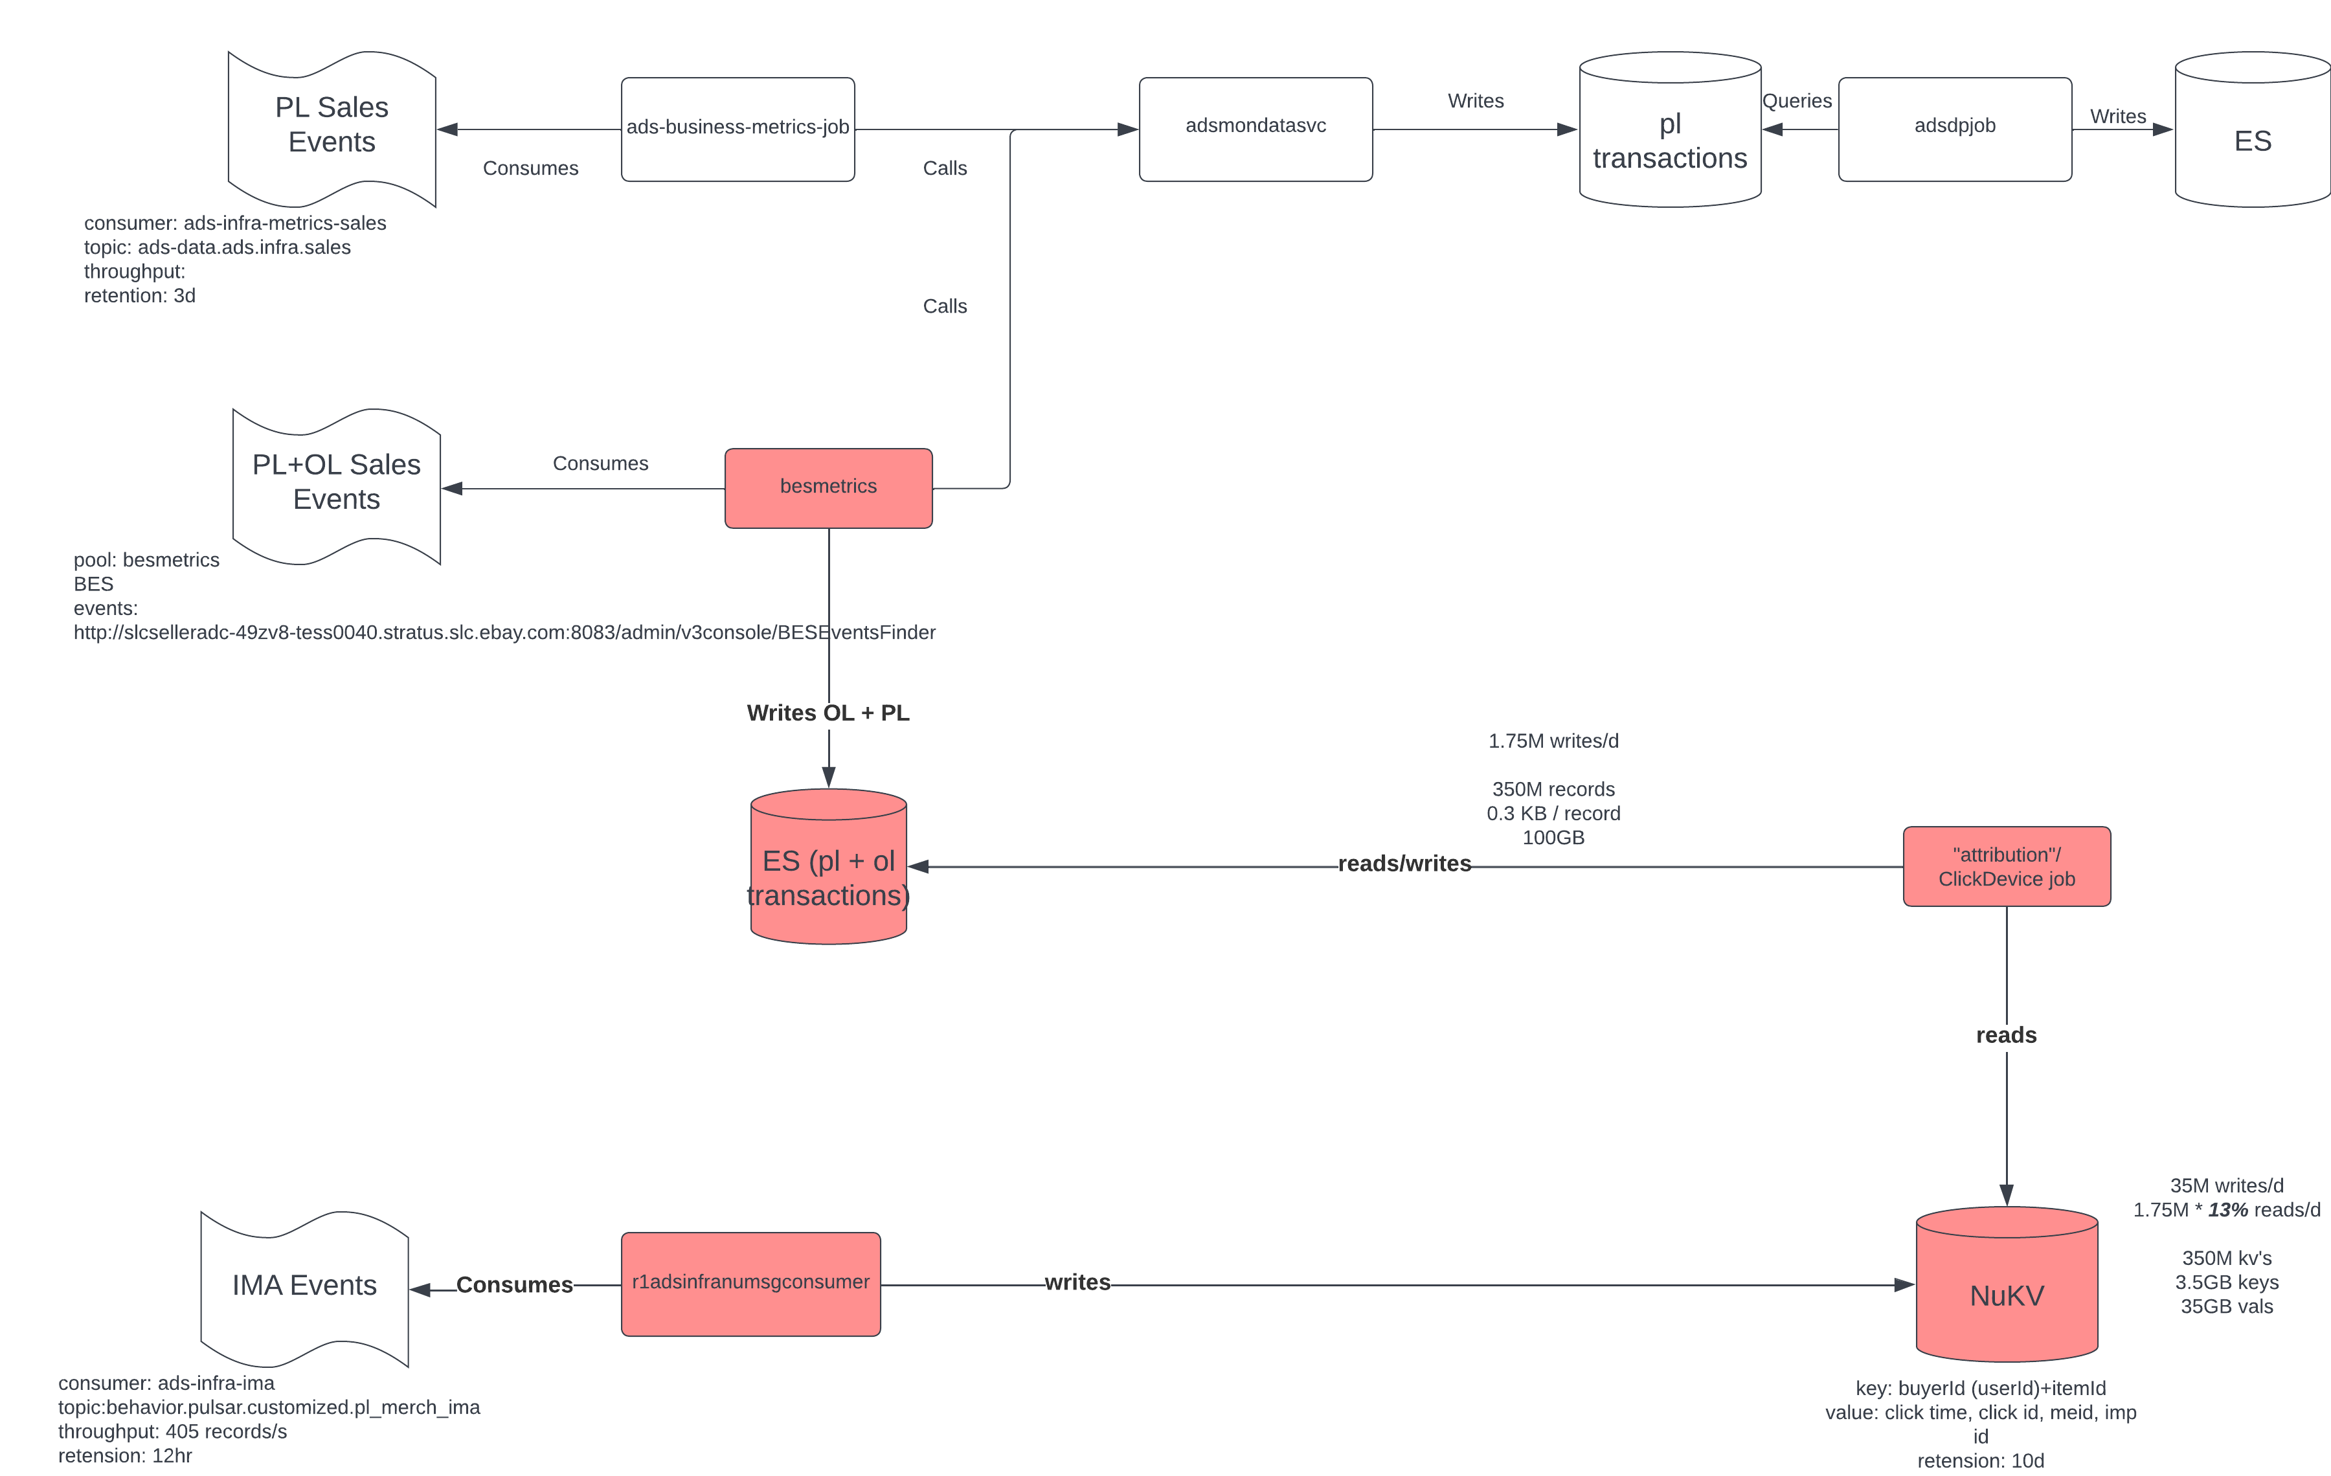

Capacity

35M Merch clicks/d

Click throughput 405 clicks/s